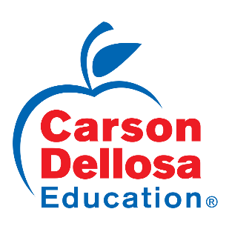

7027 Albert Pick Rd, Greensboro, North Carolina 27409

P.O. Box 35665, Greensboro, North Carolina 27425-5665

Phone 800.321.0943 Fax 336-808-3061

Children’s Product Certificate (CPC)

Certificate Number:84604618

Product Description: 846018-Community Helpers Listening Lotto

Product Compliance:

CPSIA Act of 2008

Title 16 CFR1303

ASTM F963-16 Mechanical & Physical Hazards, Flammability, Heavy Metals

Importer Name and Address:

Carson-Dellosa Publishing LLC

7027 Albert Pick Road

Greensboro, NC 27410

336-632-0084 (Phone)

Certificate of Compliance Recorded At:

Carson-Dellosa Publishing LLC

7027 Albert Pick Road

Greensboro, NC 27410

336-632-0084 (Phone)

Contact: Ellen Pyrtle

[Epyrtle@carsondellosa.com](mailto:Epyrtle@carsondellosa.com)

Manufacture Date: 1/2018

Place of Manufacture: Dongguan, China

Test Report Date: 1/30/2018

Lab: DPI Laboratory (Dongguan) Limited 